Assignment4 Prob List

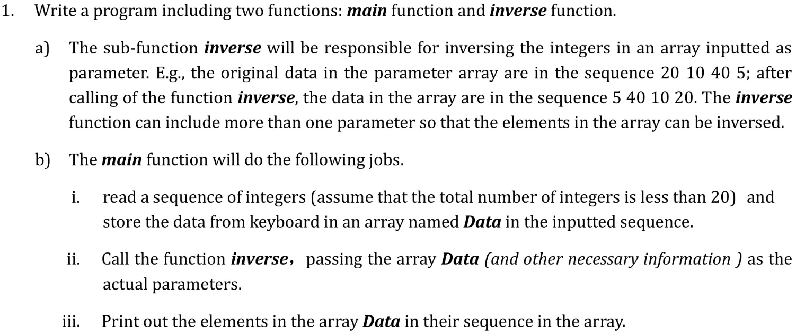

|  |  |  |
| --- | --- | --- |
| **Prob** | **Example** | **Deduction Item** |
| require extra user input, for example, ask user to input the number of integer |  | non-function |
| User need to input exactly 20 integers |  | non-function |
| wrongly name the function ***inverse*** |  | non-function |
| Simply print out Data in inverse in reverse order |  | function d |
| print out the wrong answer, but can read correctly |  | function d |



|  |  |  |
| --- | --- | --- |
| **Prob** | **Example** | **Deduction Item** |
| produce wrong answer |  | function f |
| fake recursion |  | function d |
|  |
|  |



|  |  |  |
| --- | --- | --- |
| **Prob** | **Example** | **Deduction Item** |
| number of parameters incorrect |  | function d |
| fake recursion |  | function d  effectiveness  effectiveness  codeStyle  function |
|  |
| ...... |
|  |
|  |

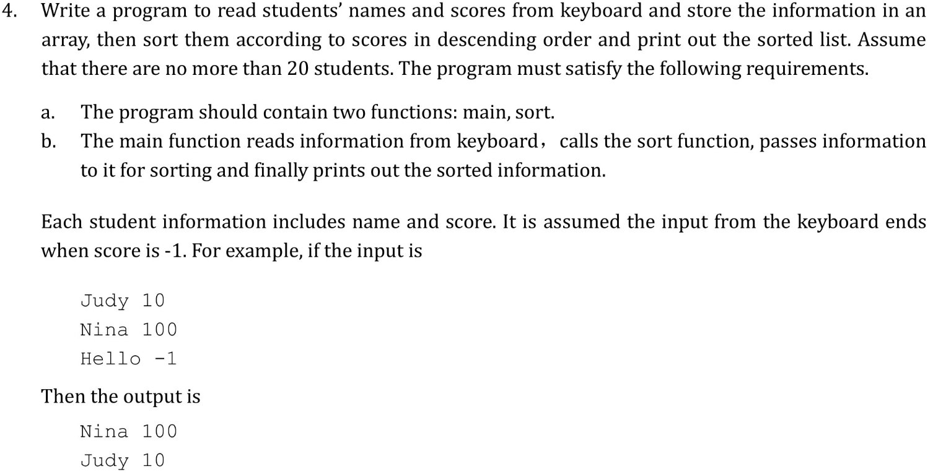

For this task, you can refer to Lab12 Task2. No more to say.

Overall

|  |  |  |
| --- | --- | --- |
| **Prob** | **Example** | **Deduction Item** |
| Plagiarize or Plagiarized | codes(except comments) similarity > 90% | All FAIL! |
| no task description at the beginning or missing info in task description |  | non-function |
| Submit the whole solution |  | non-function |
| indention improperly |  | style |
| runtime error caused by use var before declaration or use before assigning value |  | ALL FAIL! |